TASK 22
CALCULATOR APPLICATION PUSH TO DOCKER IMAGE

- Pull the docker images
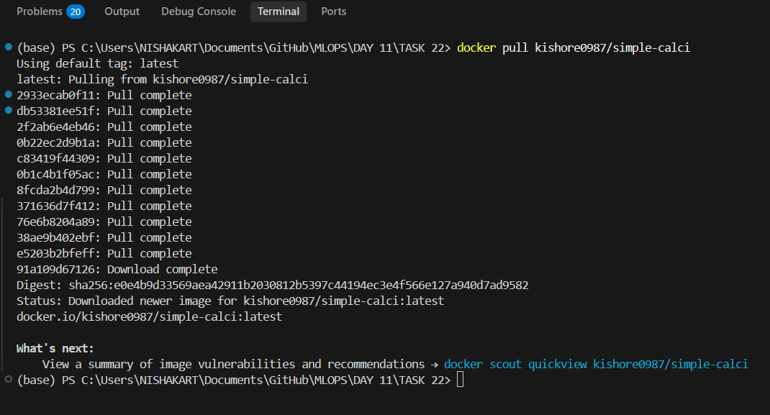

- Running the docker images:
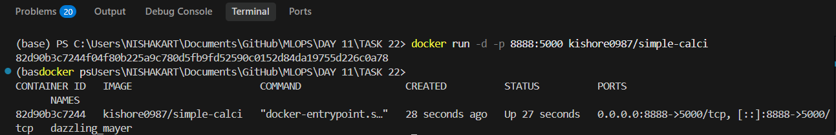

- Visiting the docker image through localhost:8000 :
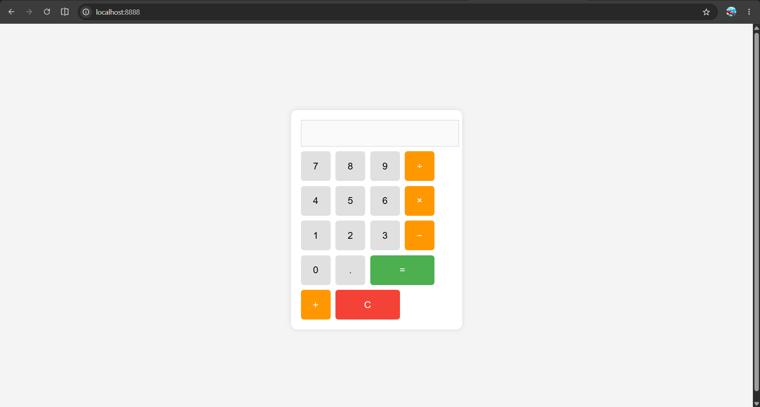

- Push the image into the docker:

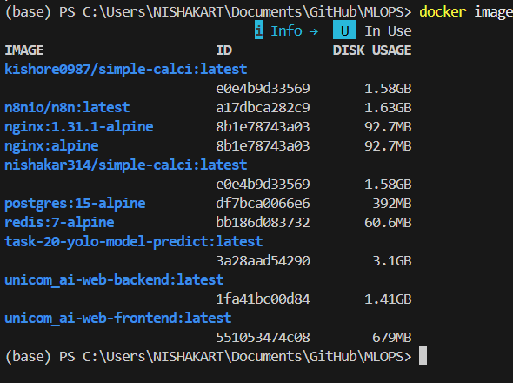

- Check whether the image is pushed into docker hub:

